PENETRATION TESTING REPORT

URL-Based Access Control Can Be Circumvented
PortSwigger Web Security Academy | Apprentice Lab
Assessment type | Controlled web application security lab
Vulnerability class | Broken Access Control
Technique | URL-based access-control bypass using X-Original-Url
Authentication | Unauthenticated access demonstrated in the lab
Result | Lab solved; administrative functionality accessed and used
Indicative severity | Critical: CVSS v3.1 9.1 (assumption-based)

1. Executive Summary
The application restricted direct navigation to its administrative endpoint. However, the back end accepted the X-Original-Url request header as an alternative way to identify the requested path. By changing this header, it was possible to reach the administrative interface despite the direct-access restriction.
The lab demonstrated access to the user-management page and the ability to invoke the account-deletion function for another user.

2. Objective
Assess whether the application’s URL-based access restrictions could be bypassed by manipulating request headers, and determine whether restricted administrative functionality could be accessed.

3. Environment and Tools
Platform | PortSwigger Web Security Academy
Tools | Burp Suite Repeater; web browser
Target | The assigned lab instance (host omitted from this report)
Testing scope | The intentionally vulnerable lab environment only

4. Methodology and Technical Walkthrough
- Baseline request. A direct browser request to /admin was made. The application returned “Access denied”, showing that direct access was restricted. (Figure 1)
- Header behaviour check. A request to / with X-Original-Url: /invalid returned HTTP 404 Not Found. This indicated that the application was processing the supplied header as a path override. (Figure 2)
- Administrative endpoint access. The request path was kept as / and the header was changed to X-Original-Url: /admin. The response contained the administrative user list and delete links, although direct navigation to /admin had been denied. (Figure 3)
- Administrative action. The request was changed to GET /?username=carlos with X-Original-Url: /admin/delete. The server returned HTTP 302 Found and redirected to /admin. (Figure 4)
- Verification. The PortSwigger lab displayed the completion message, confirming that the challenge objective had been achieved. (Figure 5)

5. Evidence
The following screenshots document the access restriction, header manipulation, administrative access, account-deletion request, and lab completion, in the order the steps were performed. Session-cookie values have been redacted in the report copies.

Figure 1. Direct access to /admin was denied.
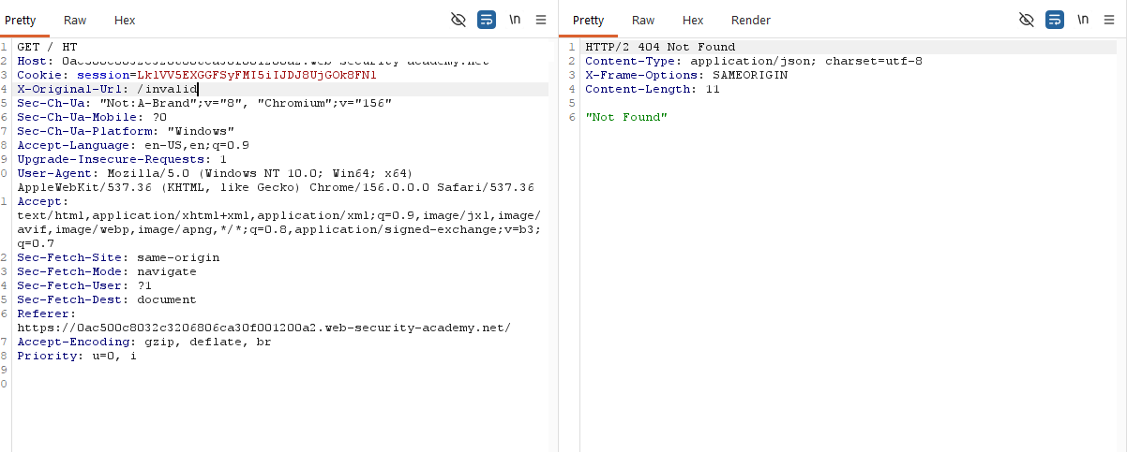
Figure 2. An invalid X-Original-Url value returned a 404 response.
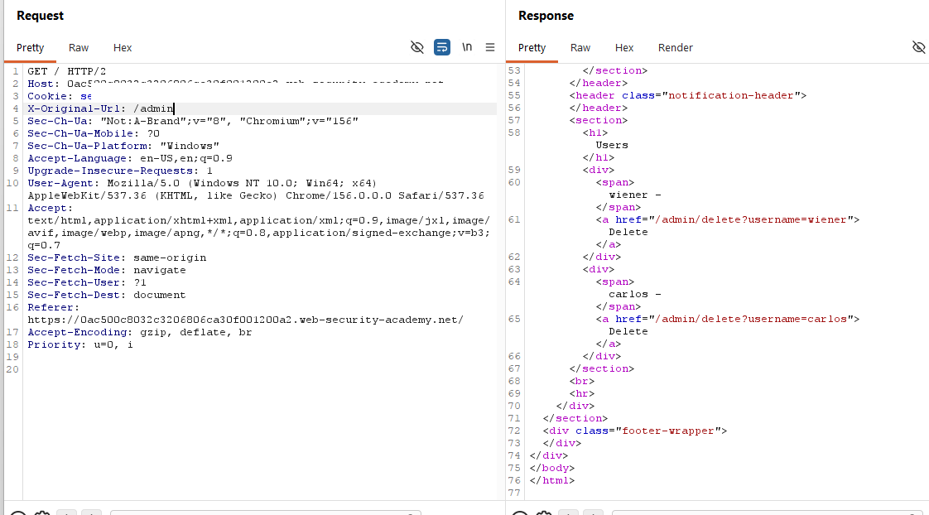
Figure 3. Supplying X-Original-Url: /admin exposed the administrative user list.
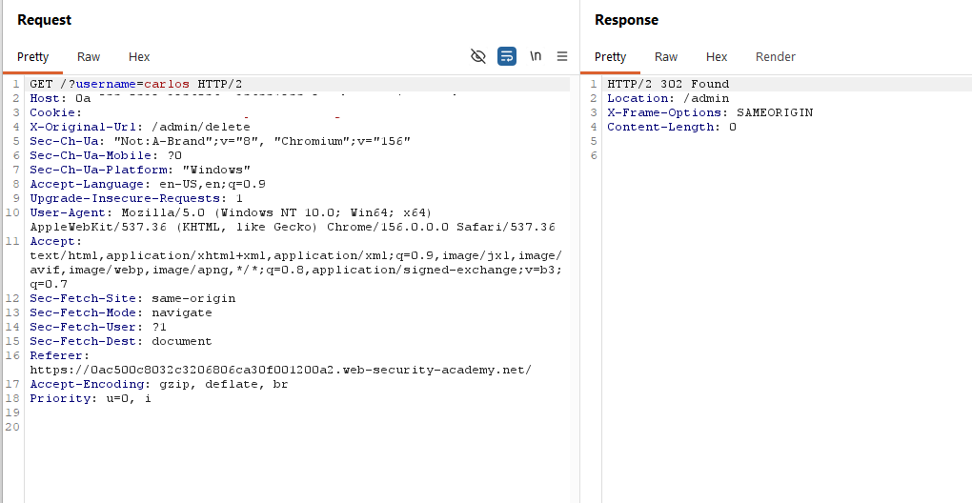
Figure 4. The request used X-Original-Url: /admin/delete with username=carlos; the server returned a redirect.

Figure 5. PortSwigger confirmed that the lab was solved.

6. Finding and Impact
Finding: URL-based access-control bypass through trust in the X-Original-Url header.

The application applied an access restriction to the externally requested URL but allowed a client-supplied header to influence the path handled by the back end. The restriction was therefore not consistently enforced at the point where the administrative operation was processed.
Impact demonstrated in the lab: an unauthenticated user could retrieve the admin user-management interface and trigger deletion of another user’s account. In a real application, the practical impact would depend on which administrative functions were exposed and whether equivalent controls existed elsewhere.

7. Severity Assessment
Indicative score | 9.1 (Critical), CVSS v3.1
Vector | CVSS:3.1/AV:N/AC:L/PR:N/UI:N/S:U/C:H/I:H/A:N

This is an illustrative score based on the lab evidence and the assumption that the administrative interface exposes high-impact information and account-management actions to an unauthenticated remote attacker. It is not a score supplied by PortSwigger or a formally validated production assessment. A real score must be recalculated against the actual application’s exposed functions and business impact.

8. CWE Classification
Recommended classification: CWE-863 (Incorrect Authorization) or CWE-862 (Missing Authorization), depending on the application’s exact enforcement design.
CWE-639 is not the best fit for this specific issue. The core problem is that authorization was not reliably enforced for the back-end administrative route.

9. Remediation
- Enforce authorization on the server for every administrative endpoint and action.
- Do not rely on client-controlled headers, including X-Original-Url, to determine whether a user is authorized.
- If URL-rewrite headers are required by trusted infrastructure, strip incoming client-supplied values at the edge and set trusted values only within the controlled proxy layer.
- Apply authorization checks after URL rewriting and routing, against the final resolved endpoint.
- Use deny-by-default access-control rules and verify permissions for each sensitive operation, including account deletion.
- Add automated tests for direct and header-based access paths to ensure equivalent authorization enforcement.

10. Conclusion
The lab demonstrated that direct access restrictions were bypassable because the application trusted the X-Original-Url header when resolving the requested route. The resulting access exposed administrative user-management functionality and allowed a user-deletion action.
Authorization should be enforced consistently on the server against the final routed endpoint, rather than relying on front-end or URL-path restrictions alone.

11. References
- PortSwigger Web Security Academy: URL-based access control can be circumvented. https://portswigger.net/web-security/access-control/lab-url-based-access-control-can-be-circumvented
- MITRE CWE-863: Incorrect Authorization. https://cwe.mitre.org/data/definitions/863.html
- MITRE CWE-862: Missing Authorization. https://cwe.mitre.org/data/definitions/862.html
End of Report

